Demand and supply housing market
Student Name
Course Unit
Date

Demand and supply housing market
The law of demand and supply explains the relationship existing between the supply and demand of a god or service and how their relationship affects the price. The housing market is influenced by the forces of demand and supply and hence serves as a perfect example of how demand and supply works within an industry. In cases were the demand for housing is high and the supply is low, the prices for homes tend to rise. When the price of the housing decreases, demand increases.
- Identify and explain two factors that have caused a shift in the demand curve. Illustrate the impact on the market using supply and demand curves. (8 marks)
Demand curve shifts are caused by factors other than price of the housing. An increase in demand will cause the demand curve to shift to the right of the demand curve. A decrease in the demand causes a vice versa effect where a shift is on the left of the demand curve. Two of the factors that can cause a shift in the demand curve of a housing market are the incomes of the people and the changes in expectations of future prices of the houses.
- Income of people
Demand for housing will depend on the incomes of individuals. The higher the income, the higher the demand for goods. Increasing incomes mean that people are able to afford to buy or spend more on housing. Since demand for housing is a luxury good, a rise in income will cause a significant percentage in rise in demand. When the rise in income of the people increases the demand, then the demand curve tends to shift rightwards or rather upward. When income decreases, demand decreases hence the demand curve shifts to the left. Increase in people’s income means that the purchasing power is high therefore people can afford to buy more. Therefore, increase in income has a positive effect on demand of housing.
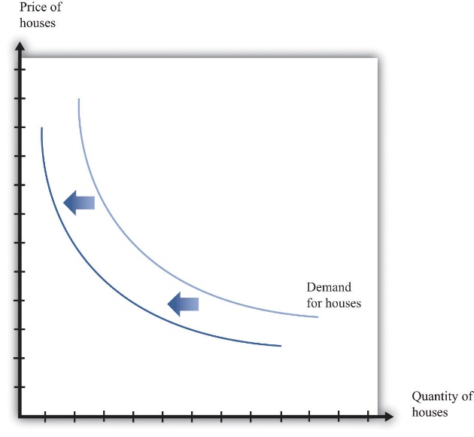
This figure illustrates that demand curve shifts to the left due to decrease in the people’s income. The purchasing power is low hence people cannot afford to buy more houses.

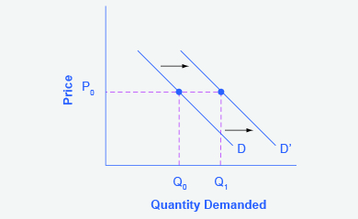

This figure illustrates that increases in income shifts the demand curve to the right. More consumers are able to afford to buy more houses.

- Changes in Expectations about Future Prices

Another factor that affects the demand curve is the expectations about the future prices of houses since this can affect demand for the houses. If the buyers expect that the future prices of the houses will rise due to unexpected economic or other conditions, then they would demand more of the houses presently so that they do not pay more prices for the same house. This effect will cause a shift in the demand curve towards the right. The same is true when the expected future prices of the houses is likely to fall, then the demand for the houses will presently be postponed hence causing a shift in the demand curve towards the left.

This figure illustrates that expectations in decrease of future prices of houses in shifts the demand curve to the right. More consumers are able to hold the purchase of houses presently and afford to buy more houses at the future price.
- Identify and explain two factors that have caused a shift in the supply curve. Illustrate the impact on the market using supply and demand curves. (8 marks)
Several factors can cause the supply curve to shift position.in the case of housing market, an increase in supply will cause the supply curve to shift to the right. When the supply decreases, the supply curve shifts inwards or rather to the left. Shift in the supply curve of housing market can be cause by several factors including changes in government regulations, weather conditions or cost of production.
- Government regulations
If the changes in government regulations are such that it makes it harder for building houses, then the shift in supply curve of the housing market will be towards the left. This means that the government regulations cause a decline in house supply. If the government regulations encourage more house building, the supply curve faces a rightward sift because more houses can be supplied.
- Weather conditions
Bad weather conditions could cause delays in house constructions or damage the constructions in the process. Bad weather condition factor causes the supply curve of houses to shift leftward. This means less houses can be supplied. The opposite is true. Good weather conditions favor fast construction hence there will be more houses available for supply. This reason will see the supply curve of the houses shift towards the right.

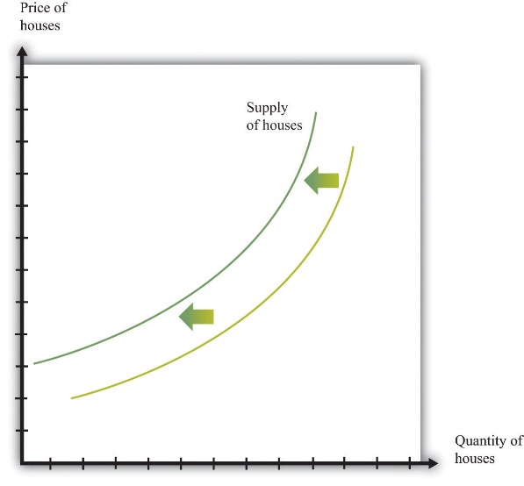
Fig 2. Illustrates that bad weather conditions and unfavorable government regulations cause a leftward shift of the supply curve of houses.
- Identify and explain one government intervention relating to this market. Explain the government’s economic objective and illustrate the impact on the market using supply and demand curves. (4 marks)
Subsidies. The government gives subsidies to encourage production and consumption. Depending on the demand elasticity, the subsidy effect is intended to reduce price and increase output. The effect of the subsidies in demand and supply sides on the housing market can be illustrated using the demand and supply curves.

Subsidies on the demand side
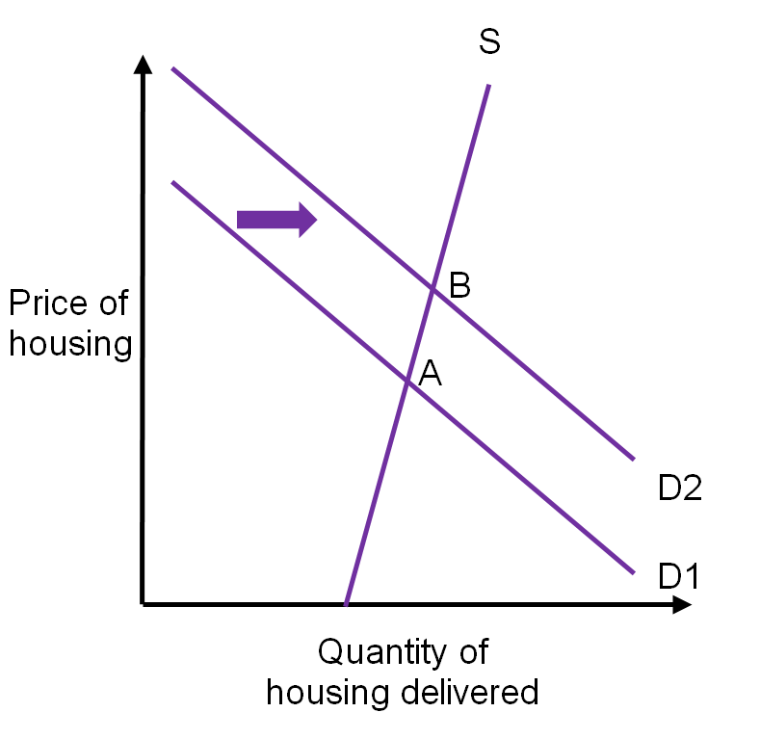
In the figure above, when housing providers fail to respond to the price rises through supply of more housing, the supply curve S will rise upwards steeply. If the demand side subsidy shifts demand from D 1to D2, the market equilibrium is also moved from point A to B. this effect therefore will cause an increase in price of the houses rather than increase in quantity delivered. The housing suppliers will reap profits from the price rise.
Subsidies on supply-side
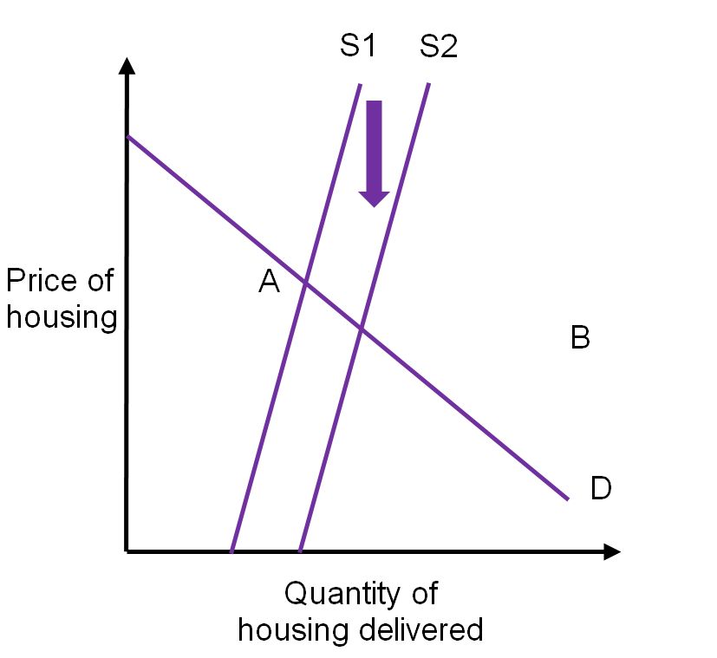

If a supply side subsidy seeks to reduce the price at which the subsidized suppliers are willing to provide housing quantity, the supply curve shifts from S1 to S2. The market equilibrium also, moves from A to B hence causing the price to decline and quantity delivered increases.

References

IGC. (2018). Housing Finance: The economics of subsidies: Supply and demand diagrams. The

International Growth Centre.
Retrieved from: https://www.theigc.org/reader/housing-finance/economics-subsidies-supply-demand-diagrams/
Singh, J. (2019). 6 Important Factors That Influence the Demand of Goods

